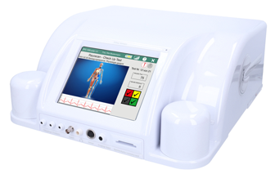
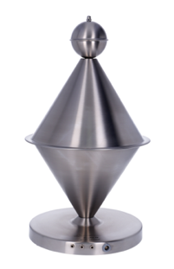
Monday June 22, 2026
185 Frobisher Dr. Waterloo
7:00 pm (Doors open 6:30pm)

Cost: FREE


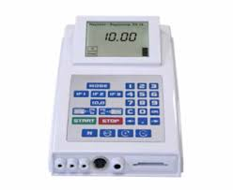
With Presenter: Sheryl Ellis-Potier

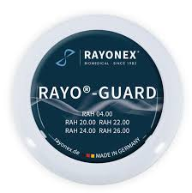
Join us to learn about this revolutionary

technology that is changing the way
we bring ourselves back to well-being!

Based in the science that everything -including our human bodies- is vibrational, Rayonex Biomedical has developed devices and protocols that can both analyse and harmonize vibrational patterns of organisms.

Our bodies are self-regulating organisms. It is when an organism comes under a stress of some sort, either physical (e.g. injury; bacteria), or psychological (e.g. trauma; emotionally stressful situations), that the physical state of the body gets altered – electromagnetic vibrations become disturbed, and thus cells become damaged.

The devices produced by Rayonex Biomedical GmbH are able to measure the energy wavelengths coming from cells within the body, allowing for the detection of energetic disturbances (energetic burdens) in the organism, and for the harmonization of the cellular vibrations. Through emitting the frequencies, cells are stimulated and are able to regulate back to their natural vibrational state.
Harmonization of the cells stimulates the cells back to a state of self-regulation, creating an overall state of well-being.

This process focuses on supporting the natural self-regulation of the body.
This phenomenon is called bioresonance.

‘Bioresonance according to Paul Schmidt’ (BaPS) is a specialized way of working with frequencies to support organisms, using a cause-oriented approach. It has been proven for over 50 years around the world.
BaPS can be individualized to each client, to both detect and address specific issues/concerns.
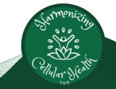

~~~~~~~~~

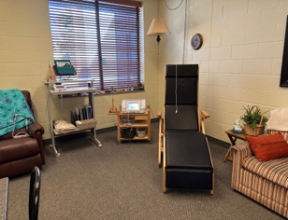
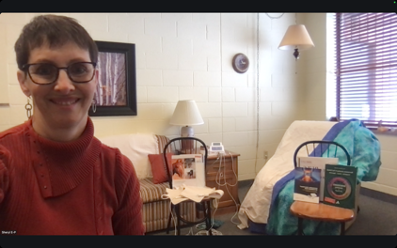
Sheryl is a retired school teacher who has always had an interest in health and wellness. She found the bioresonance approach through dealing with a number of both personal and family health challenges, was very impressed with the results achieved, and initially invested in a device for personal well-being. She then decided to become certified, and to support others’ well-being through ‘Revitalizing Wellness Bioresonance’.

As a Certified Practitioner in Bioresonance according to Paul Schmidt, Sheryl is excited to support both people and animals, using this bioresonance technology.

